PURCHASE ORDER NOTES BY VENDOR or ITEM

To have notes transfer from the vendor file to every new purchase order, there are a few simply steps.

Step One – Group Notes on PO:
Add a new user group called PO under N-C for change user group.

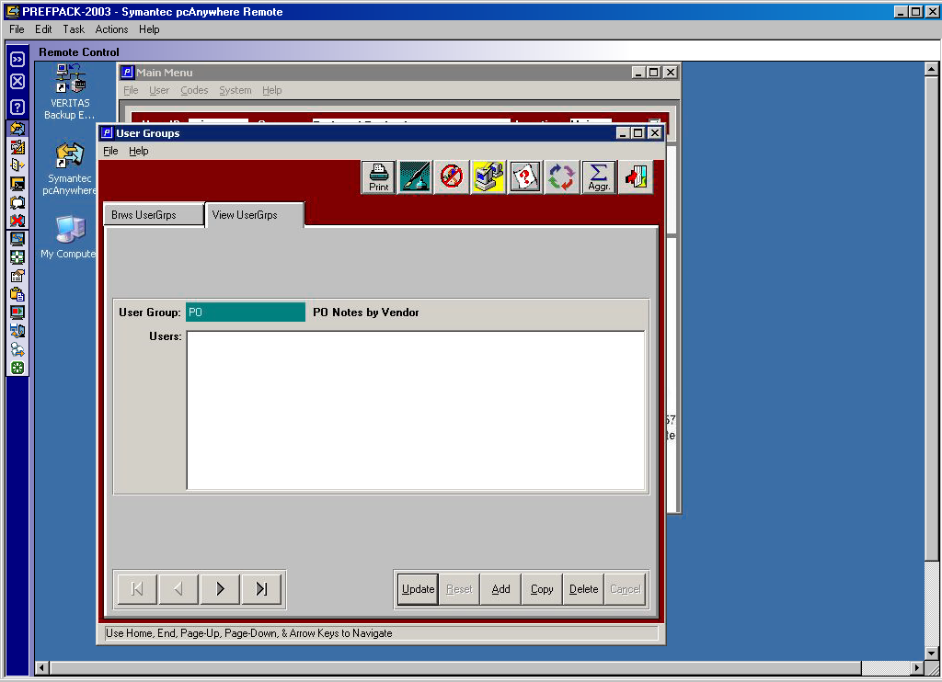

Step Two – Group Notes on PO:

Add notes to a specific vendor via the BOOK Icon.
Access the vendor under V-F-1. Then click the Book Icon, then click the View Folder.
Add the notes for PO group. This will transfer to the fountain pen icon on the view folder of the purchase order when a new purchase order is added.

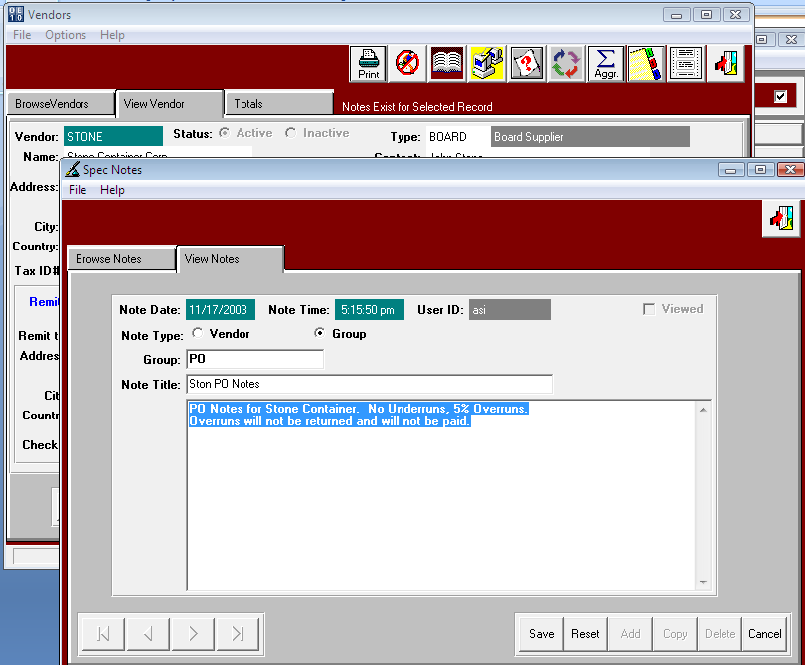
Step Three – Group Notes on PO:

Add a new purchase order and notice the message that notes exist.
Click the Fountain Pen from the PO View folder to verify the transfer.

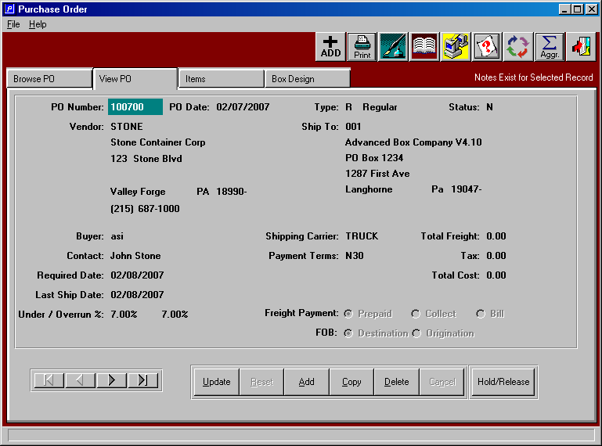

Step Four – Group Notes on PO:

Click the Fountain Pen Icon and notice the notes from the Vendor file transferred.

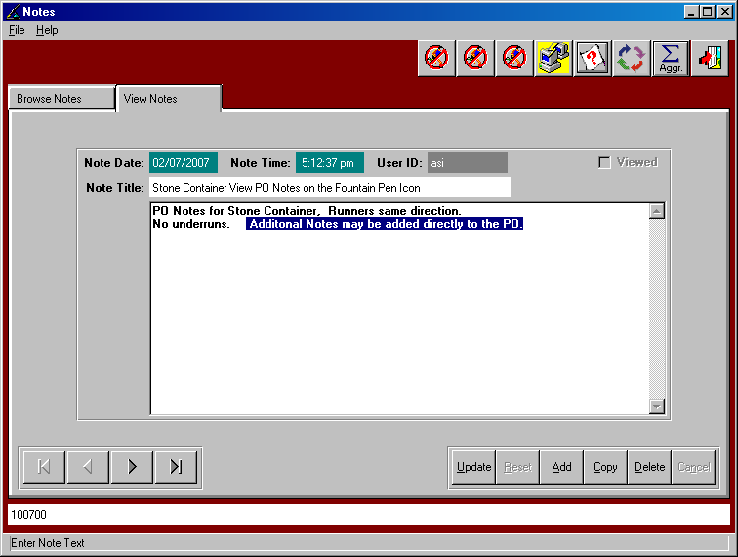

SPEC Item Notes on PO:

You can also add notes that will be raw material or finished goods item code specific. These notes will be PO line item notes as opposed to PO header notes.
For example, if you want a note on every 200 C line item you would follow these steps.

Step One SPEC Item Notes on PO:
Add a new user RM Specification code (at N-Z-6) called PO.

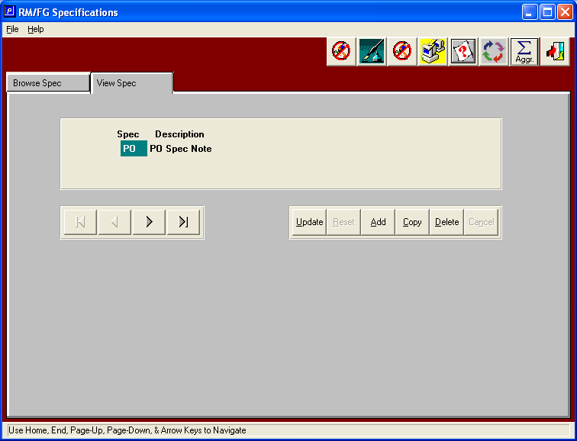

Step Two SPEC Item Notes on PO:
Add notes to a specific raw material code via the BOOK Icon.
Access the raw material code under M-F-1 or M-F-2. Then click the Book Icon, then click the View Folder.
Add the notes for PO spec code. This will transfer to the fountain pen icon on the “items” detail folder of the purchase order when a new purchase order is added.
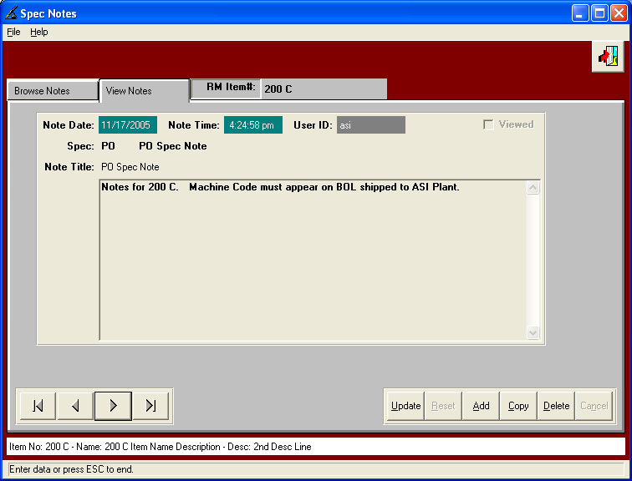

Step Three SPEC Item Notes on PO:
Add a new purchase order with a line item for the raw material code that you added the note for (in our example 200 C).
Click the Spec Book Note button verify the transfer.

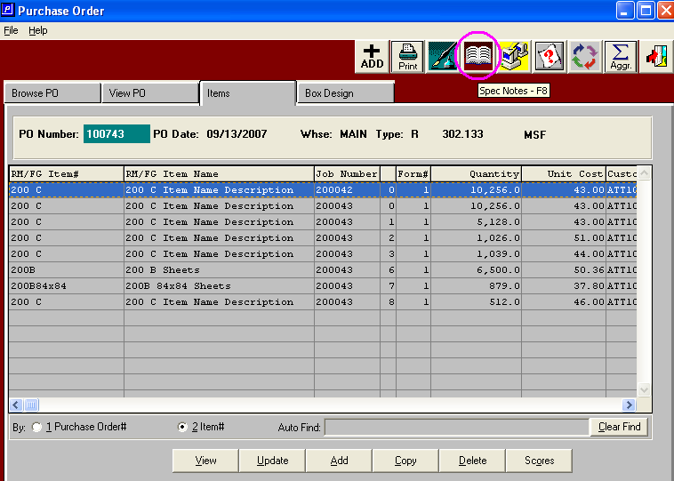

Step Four SPEC Item Notes on PO:

The book note folder shows the notes added for the specific raw material code.
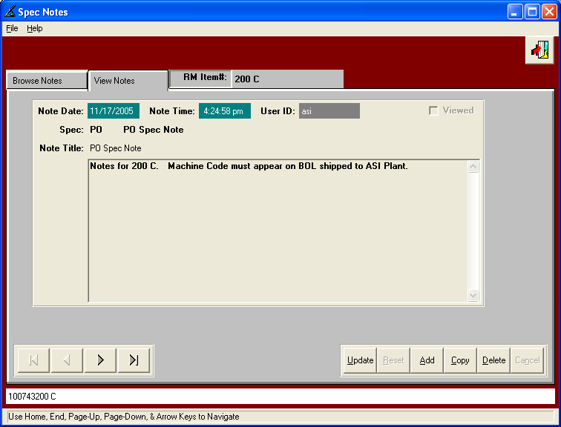

Depending upon which PO form you select, both the header notes and the line item notes are available to print on the purchase order.

